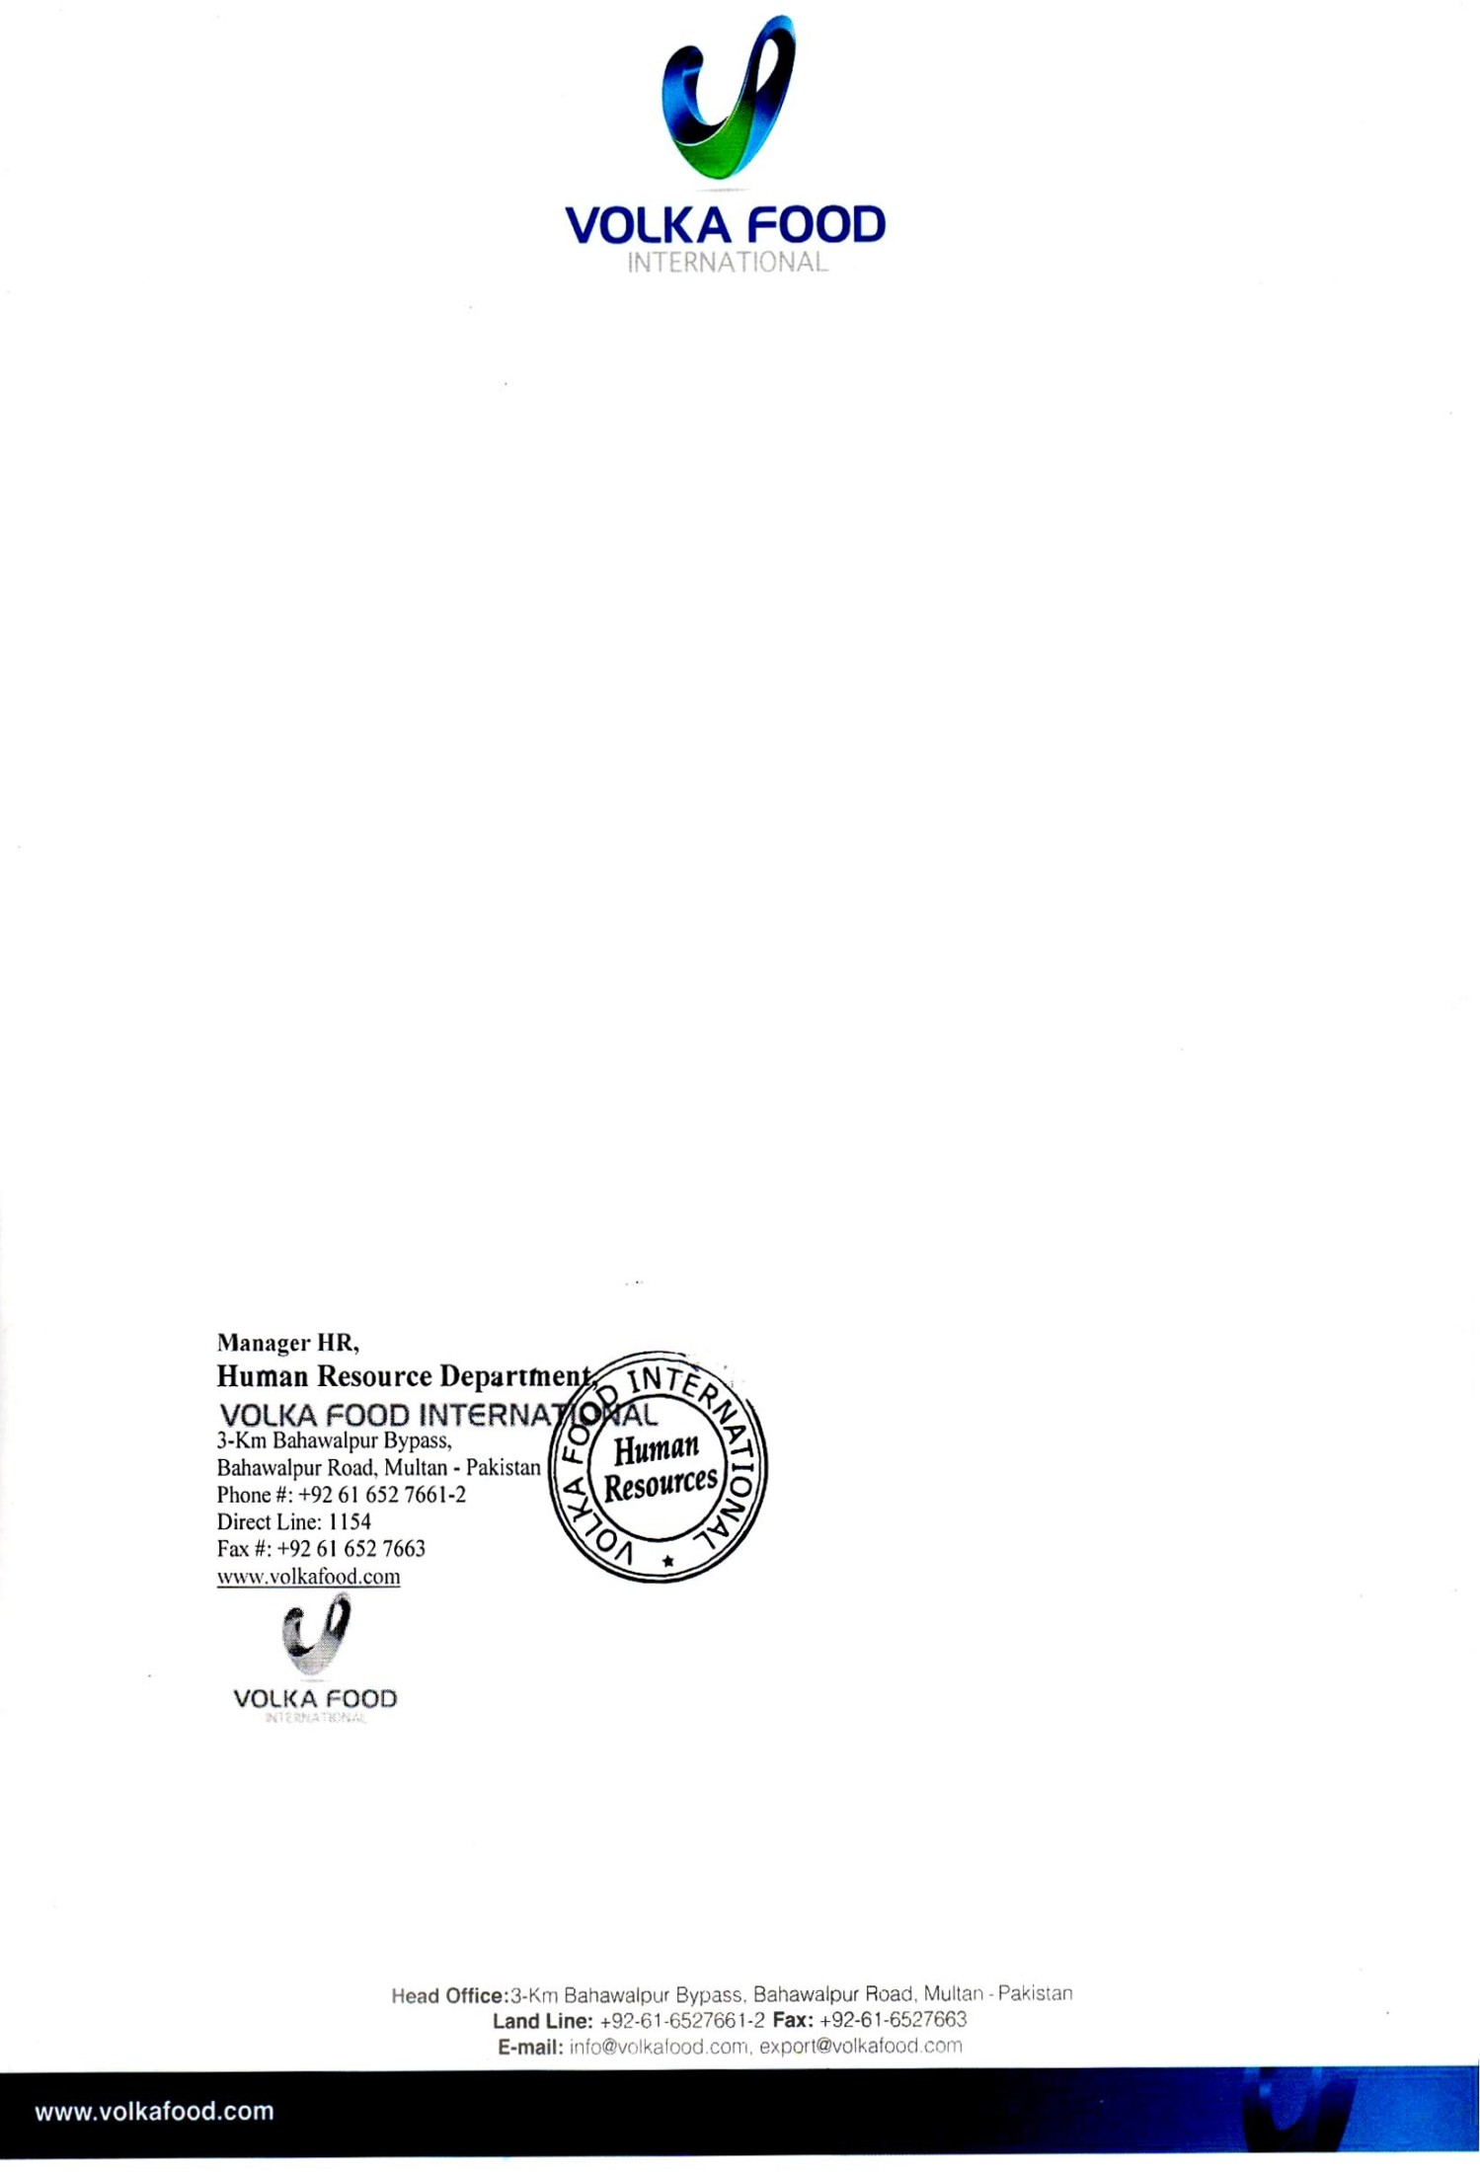

**Ref: VFI/HR/858 Date:** <To>

TO WHOM IT MAY CONCERN

It is certified that **Mr**. **<Name>** S/o **<fname>** worked with this organization w.e.f. **<From>** to **<To>** as a <Designation> at **<Designation> Department.**

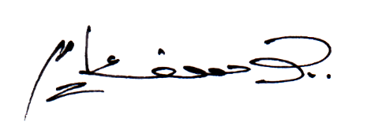His performance has been exemplary and to the entire satisfaction of his superiors. He is professionally sound and his approach to his work indicates zeal and enthusiastic to learn. He is an honest, punctual and devoted person. He bears a good moral character.

**Head Office: 3-Km Bahawalpur Bypass, Bahawalpur Road, Multan - Pakistan Land Line: +92-61-6527661-2 Fax: +92-61-6527663**

**Email:** [**info@volkafood.com,**](mailto:info@volkafood.com) [**export@volkafood.com**](mailto:export@volkafood.com)